1. 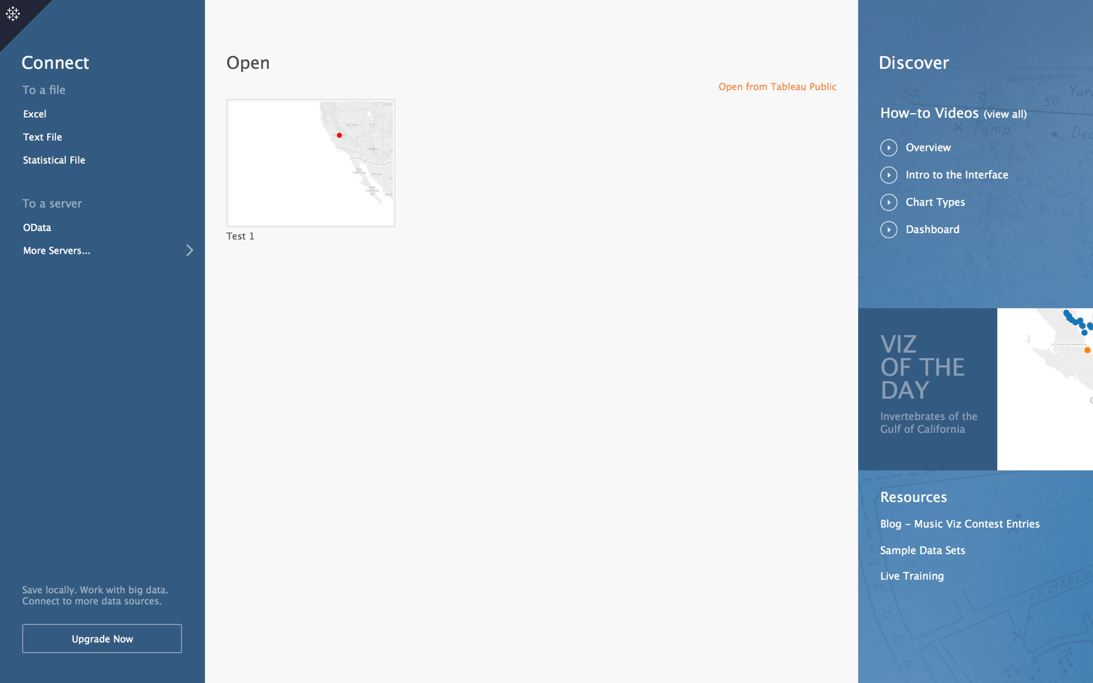**Importing Data into Tableau:**

**Left Side:**

Under “Connect” click on Excel and choose the file with your data.

Spread sheet

1. 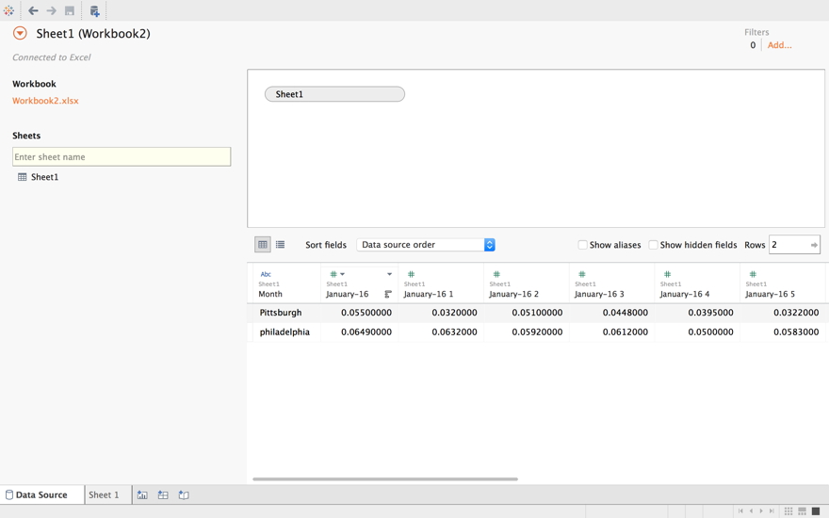**Formatting your Data:**

Workbook

Your file will open as a ‘data source page’ where you will see the file name under **Workbook** on the left, and a spreadsheet of your data on the right.

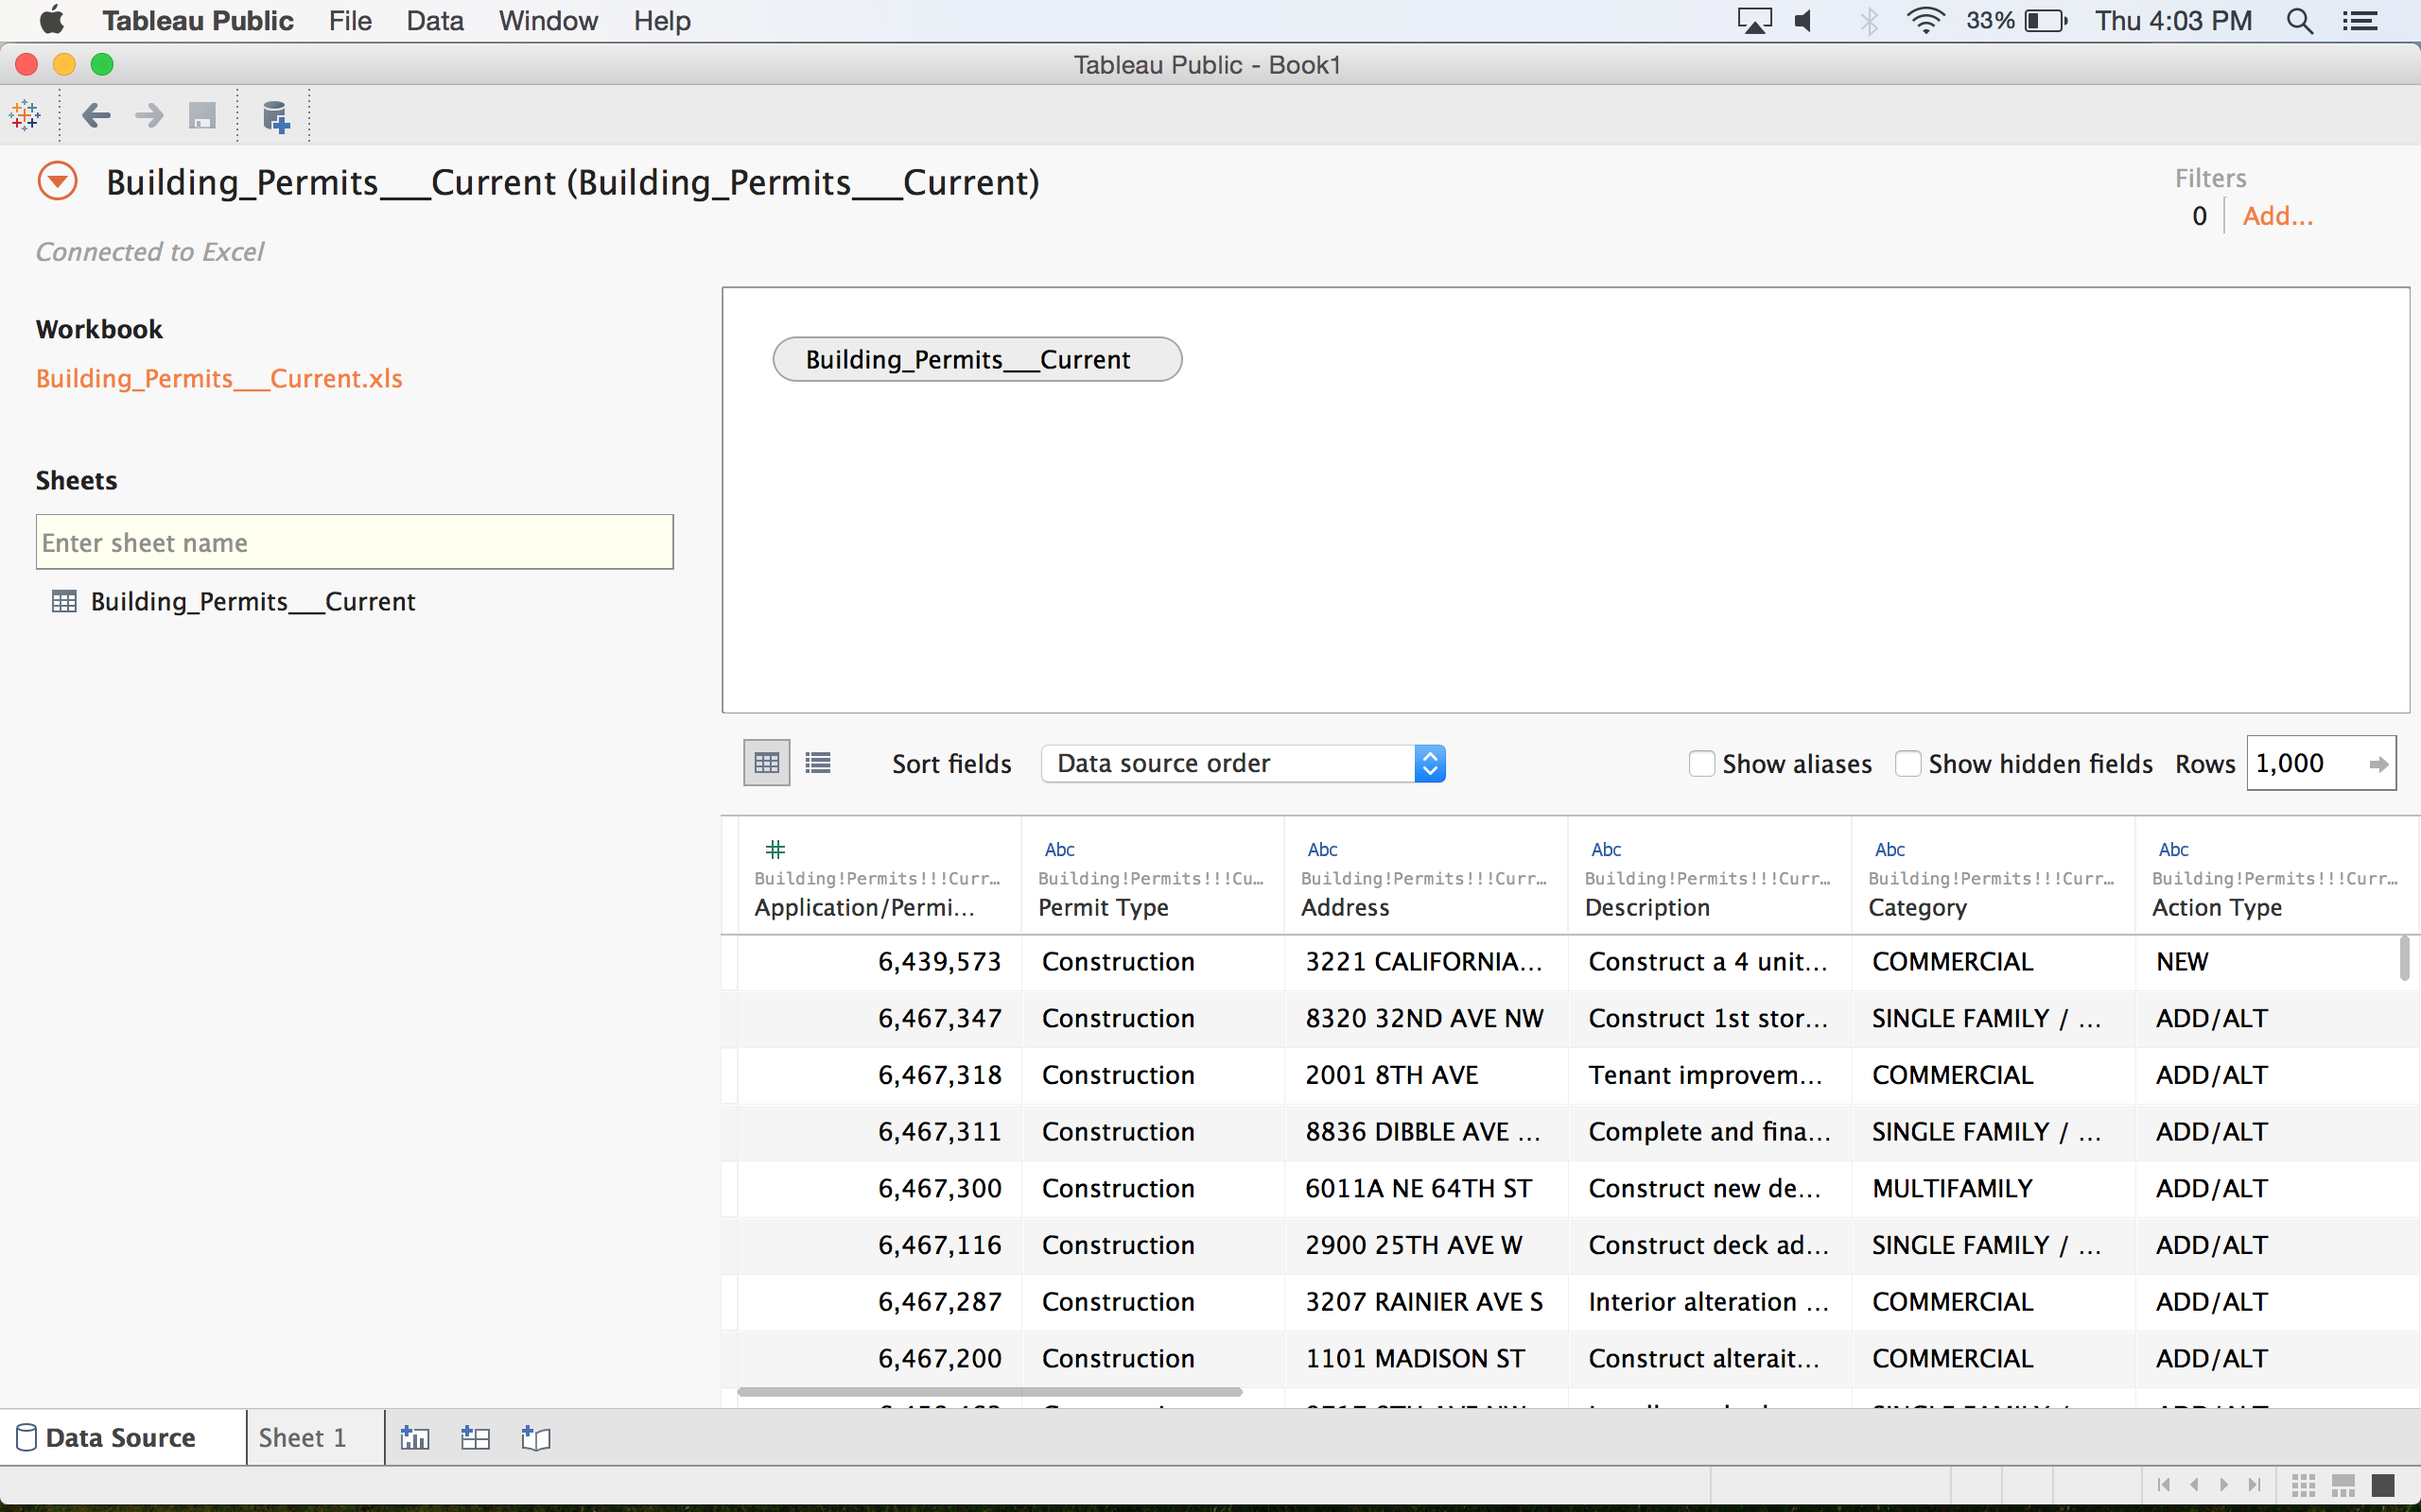“String”- for Labels

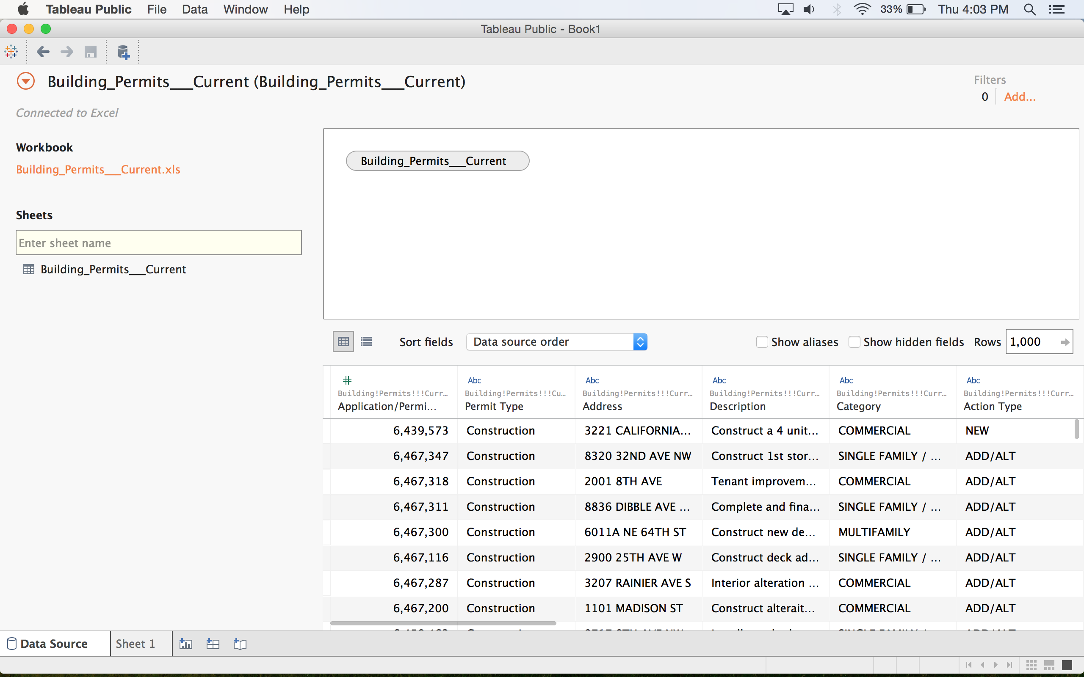 “Numbers”- for whole numbers

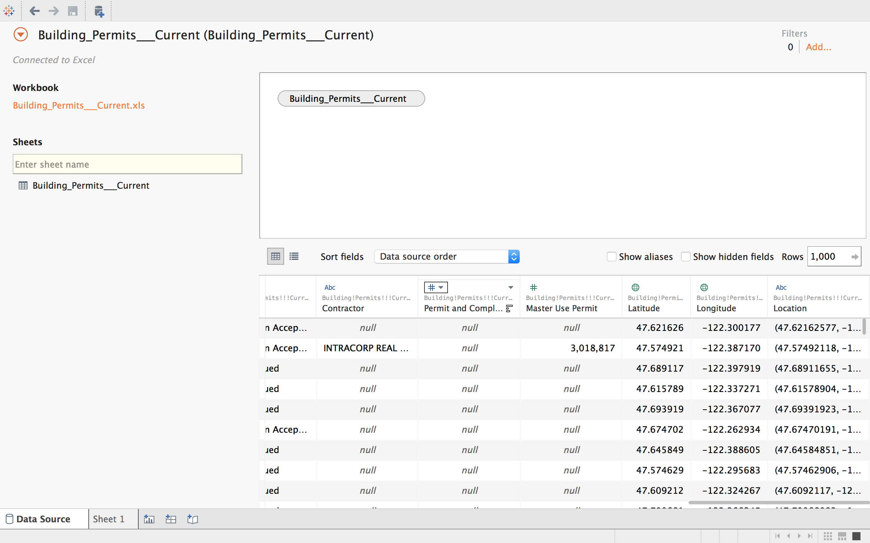 “Numbers”- for decimal numbers

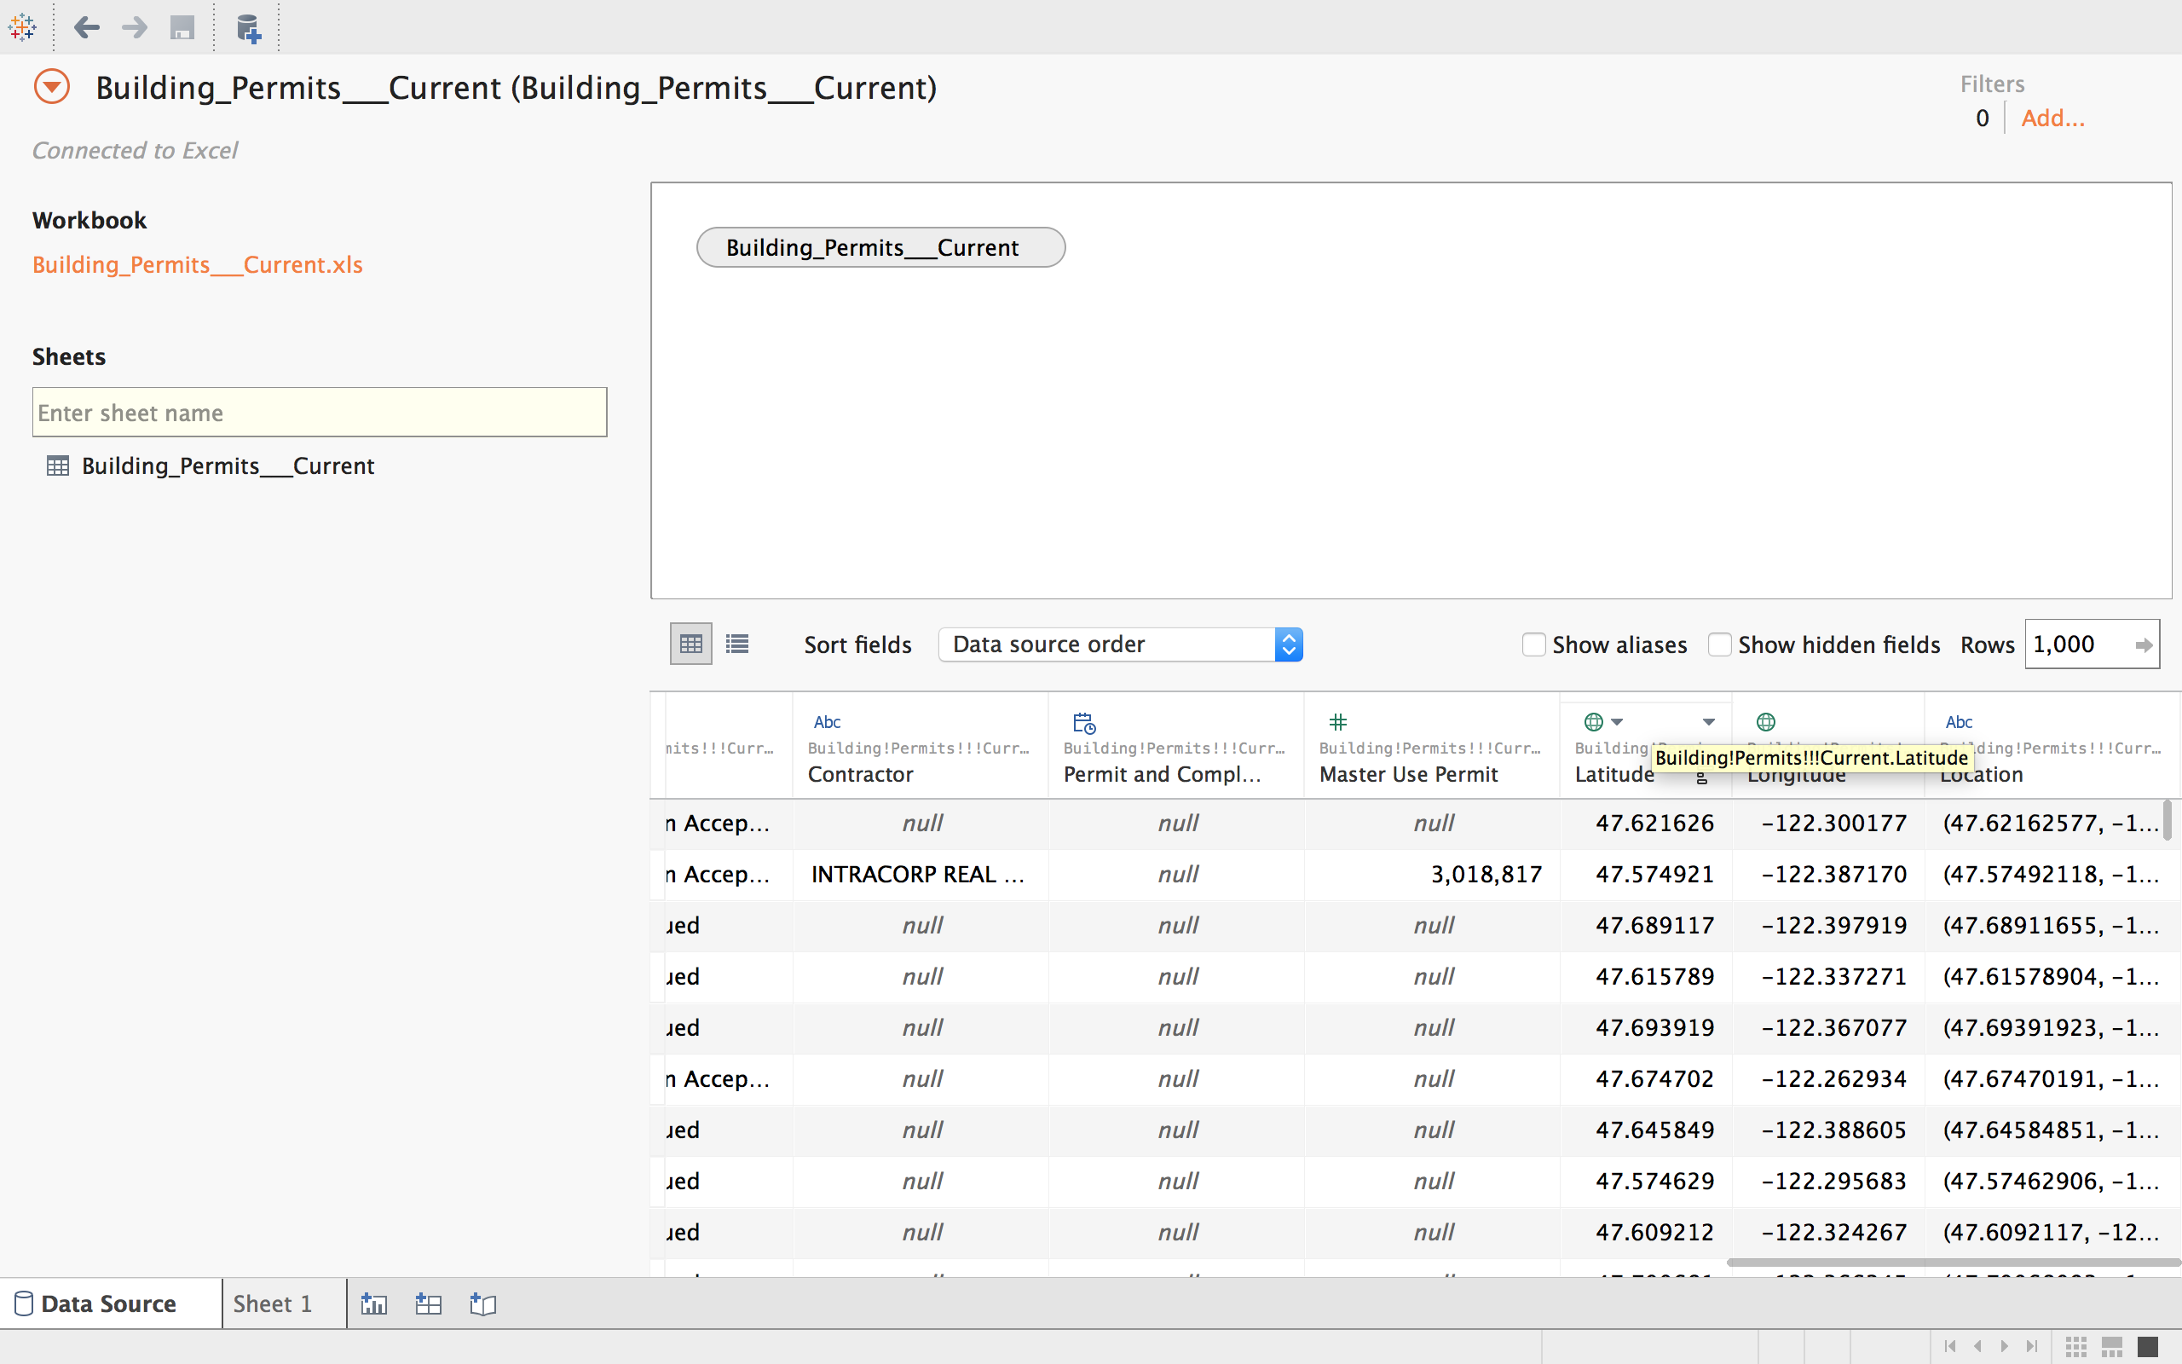 “Geographic”- For exact locations

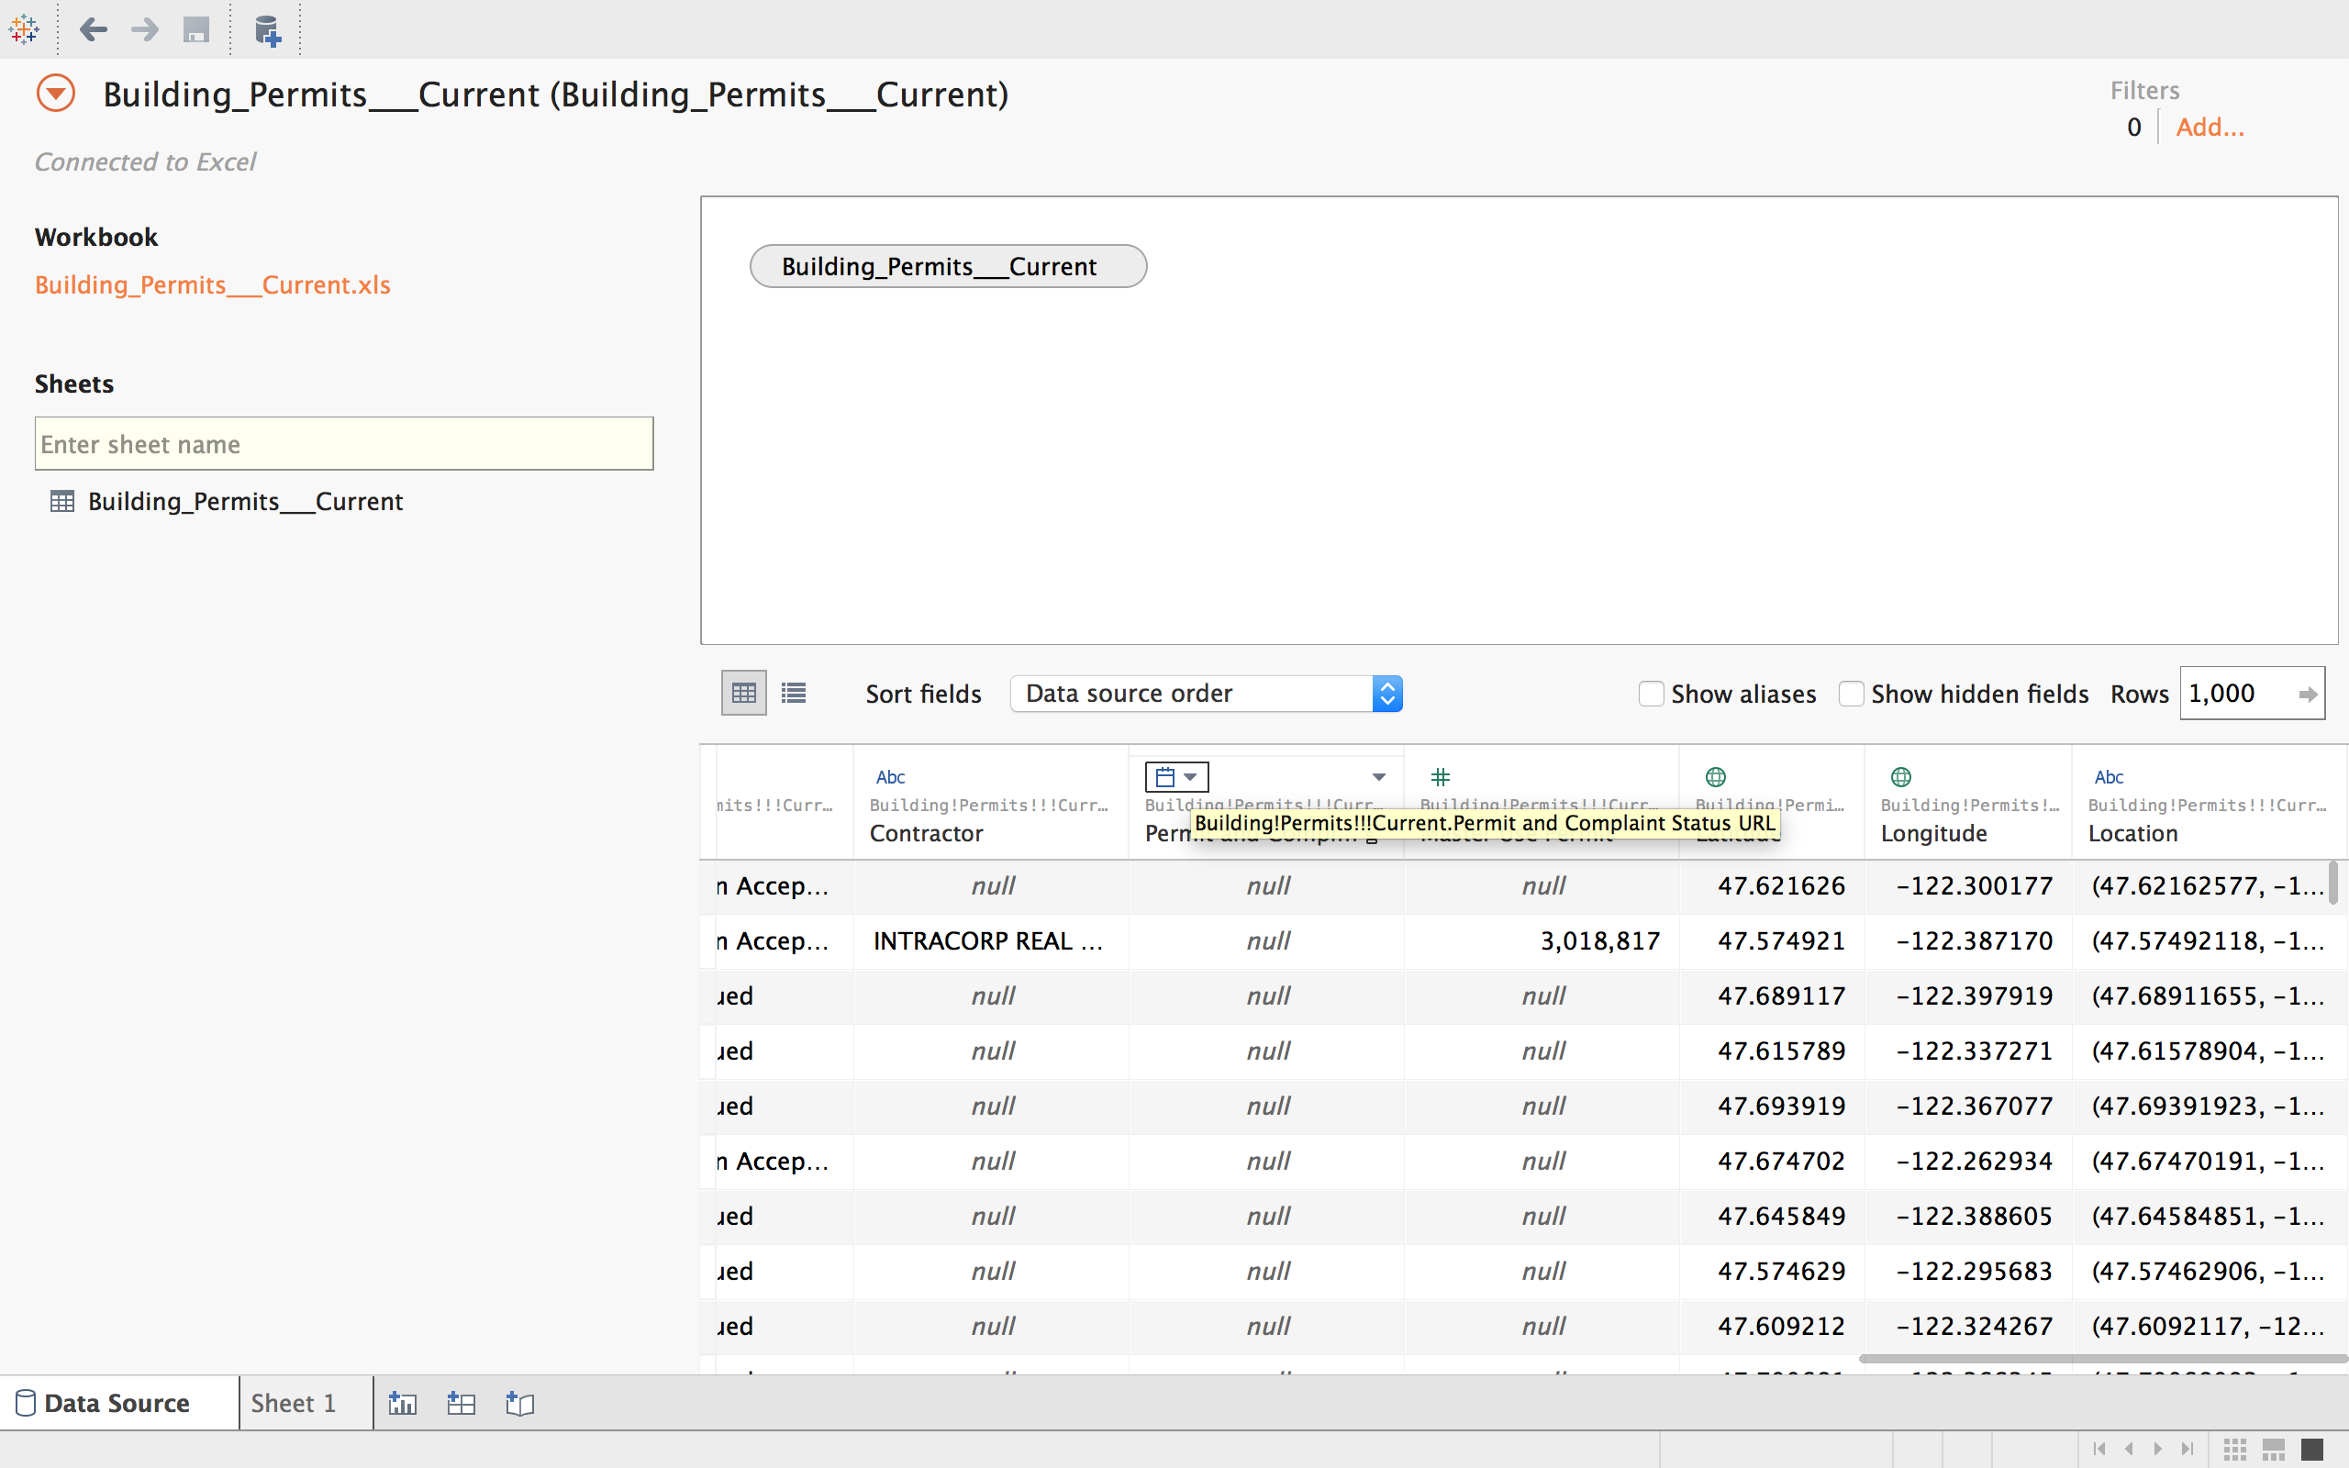 “Date”- for dates

“Date & Time”- for both date and time

At the top of each column there will be an icon that categorizes your data. If you feel the data is wrongfully categorized, change the icon using the arrow to the right of the icon.

When you are finished click on **Sheet 1** at the page bottom**.**

1. **Graphing Your Data:**

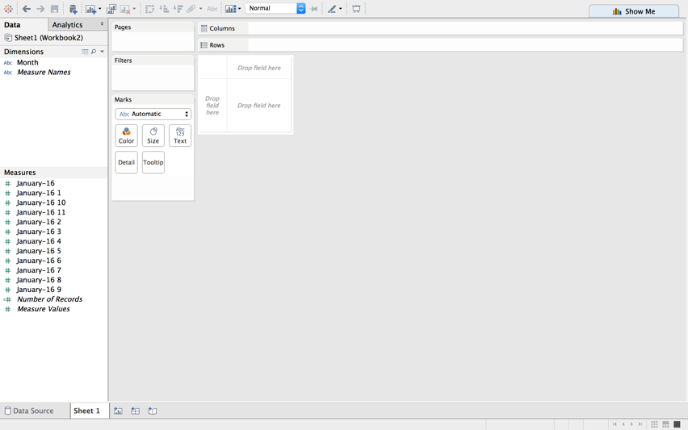Sheet 1 will act as a canvas where you can design your graph.

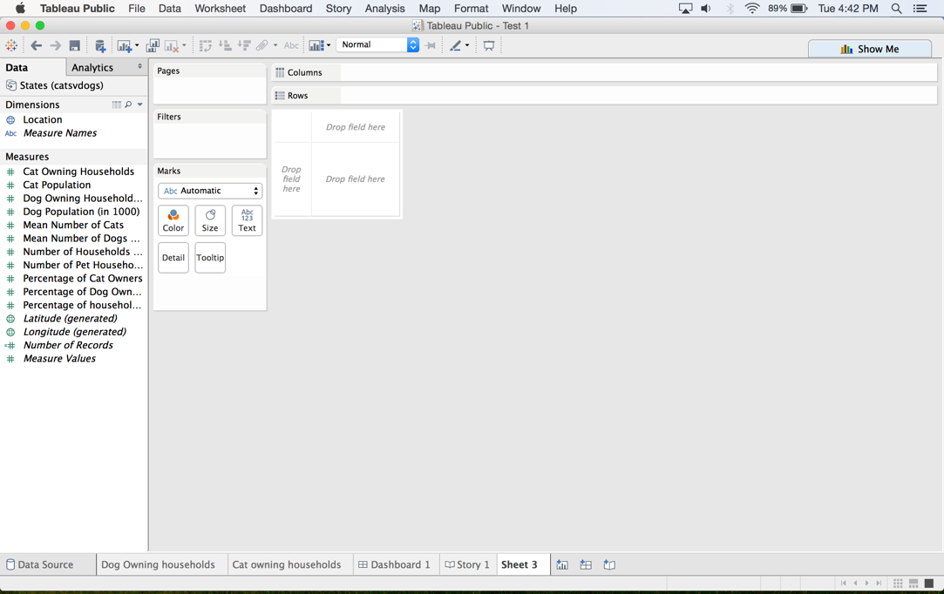

Decide what dimension(s) and measure(s) will be displayed on the x axis and the y axis. Then click and drag that data to either **Columns** for x-axis or **Rows** for y-axis. Once the axes are arranged a graph will appear.

1. **Choosing Graphs:**

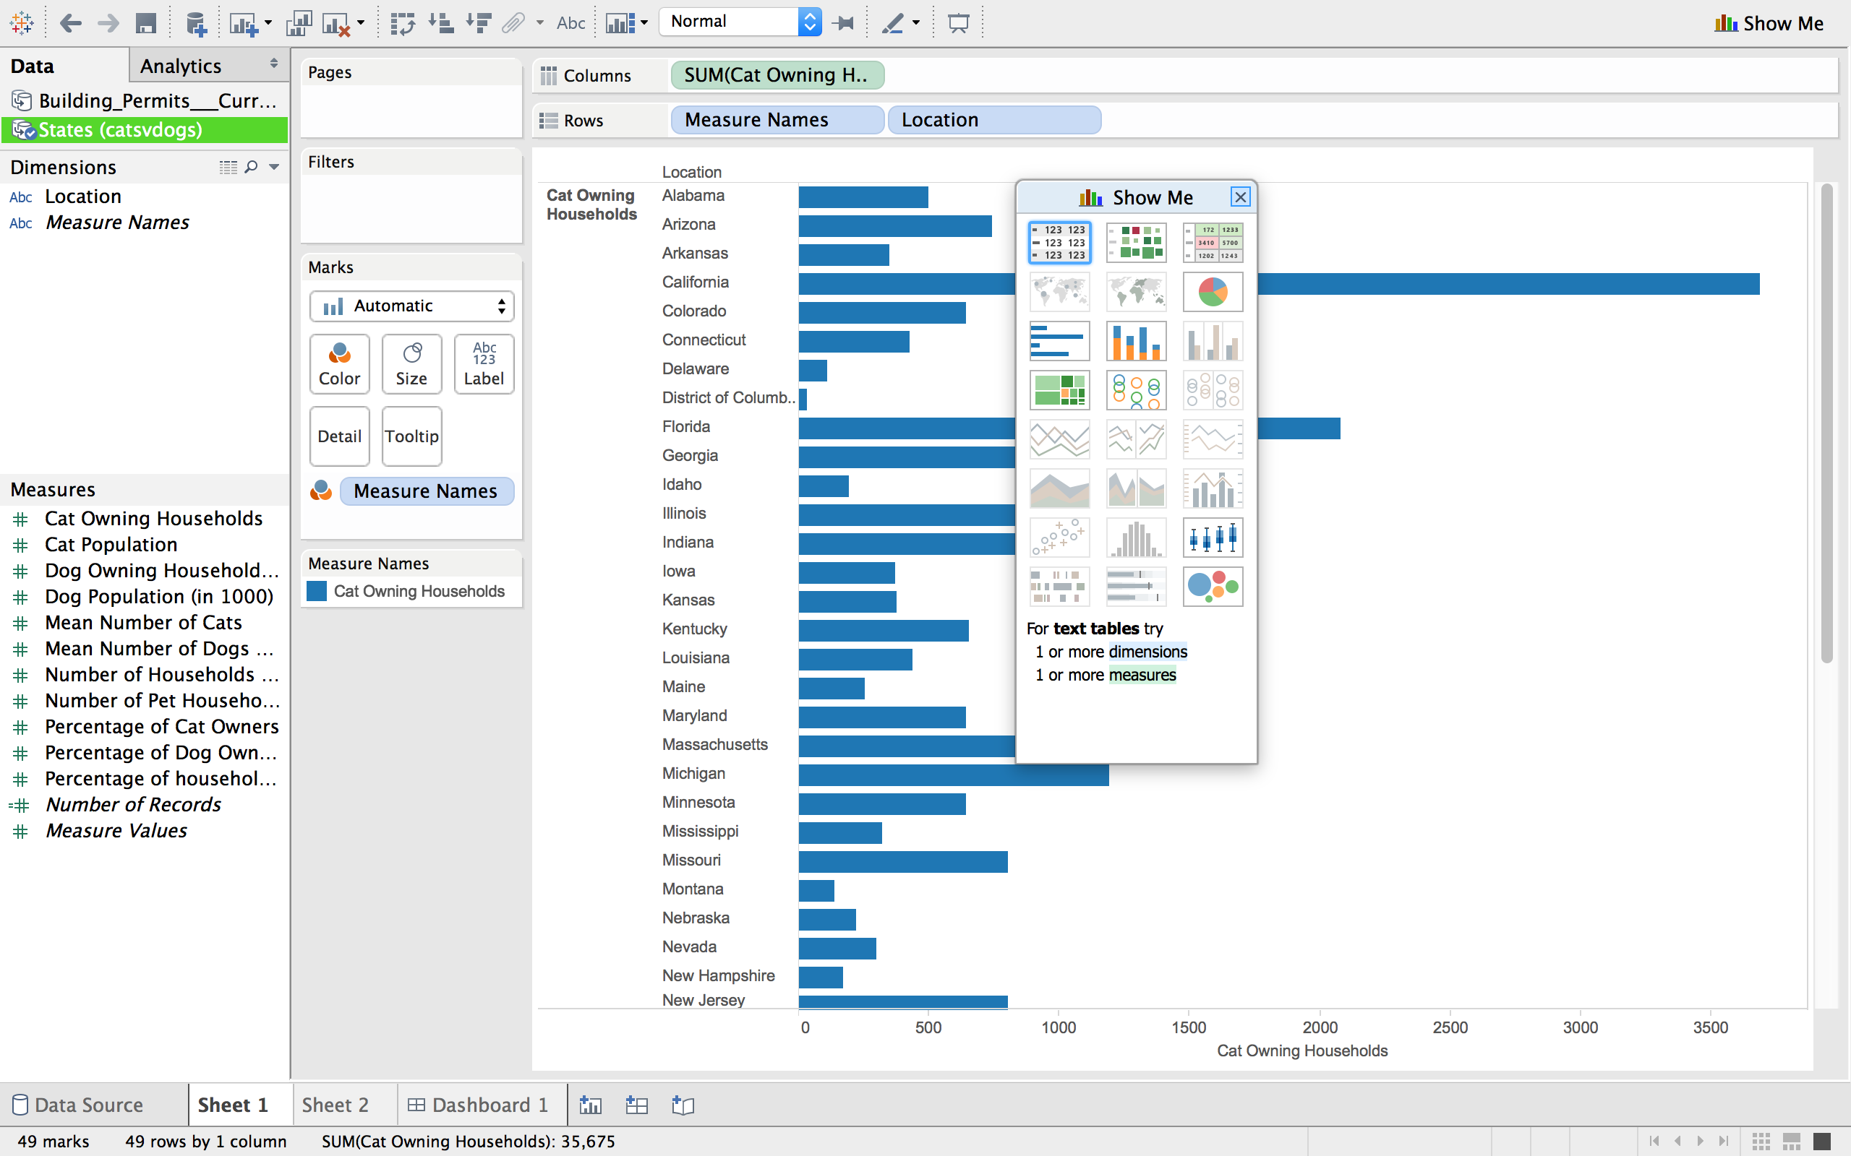

The **Show Me** side bar is located on the top right of the screen and shows graphs (highlighted) that will work best with the selected dimensions and measures. Changing dimensions and measures will alter which graphs are highlighted.

By hovering over a graph the criteria

needed to make that graph available

will appear below the graphs.

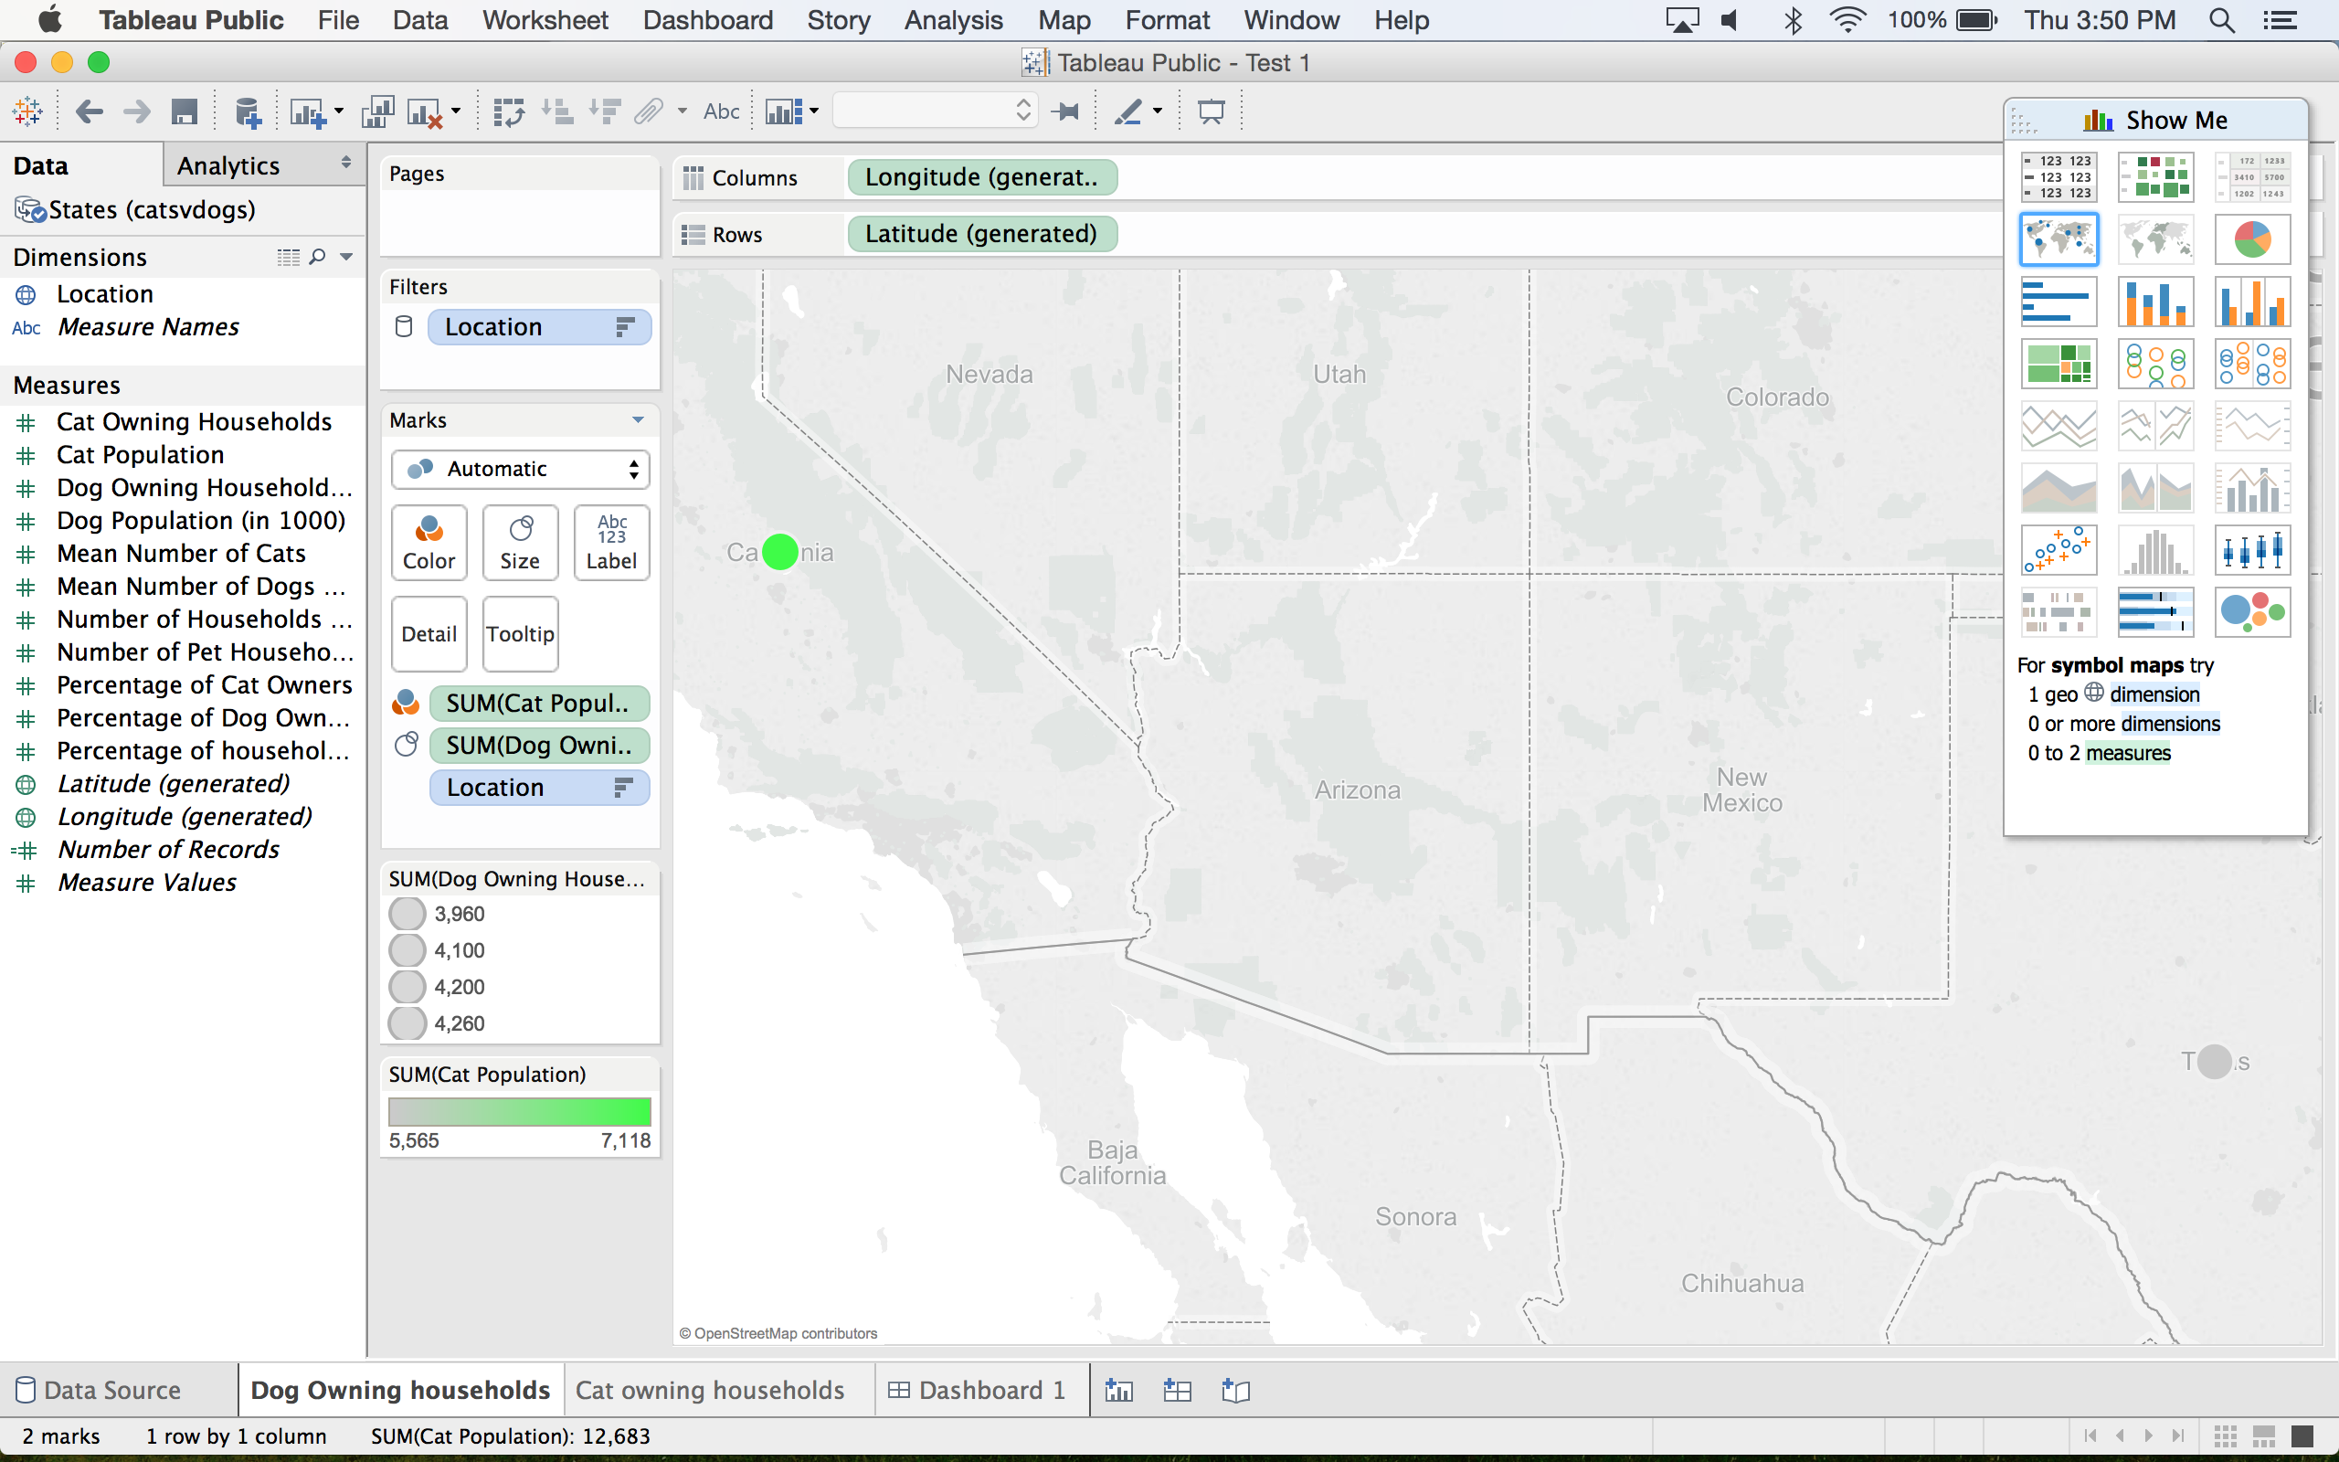If the highlighted graphs are not what you want, by clicking the first tab on the **Marks** box (on left side of screen) you can select another graph.

1. **Detailing the Graph**

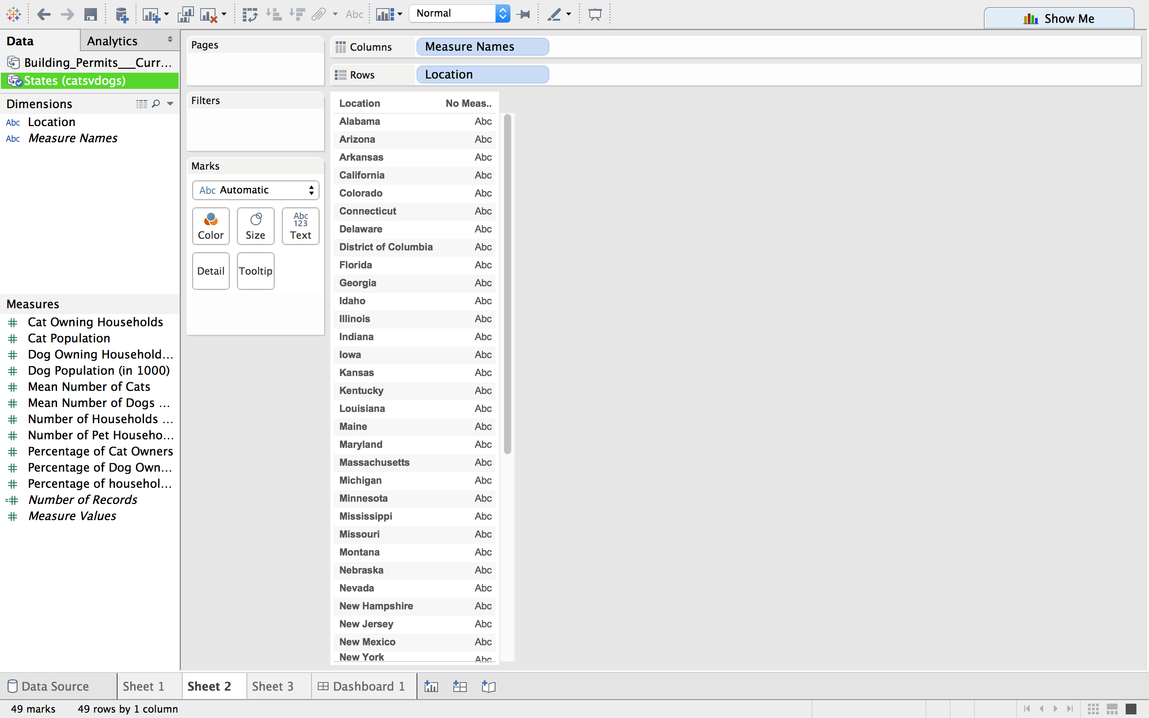

**Changing Color:** To identify a certain dimension or measure by color drag it from the left side bar and place it on the “Color” icon.

**Changing Size:** To identify a dimension or measure by size drag it to the “Size” icon.

**Text:** This icon changes the text font on the graph.

1. **Creating Multiple Graphs**

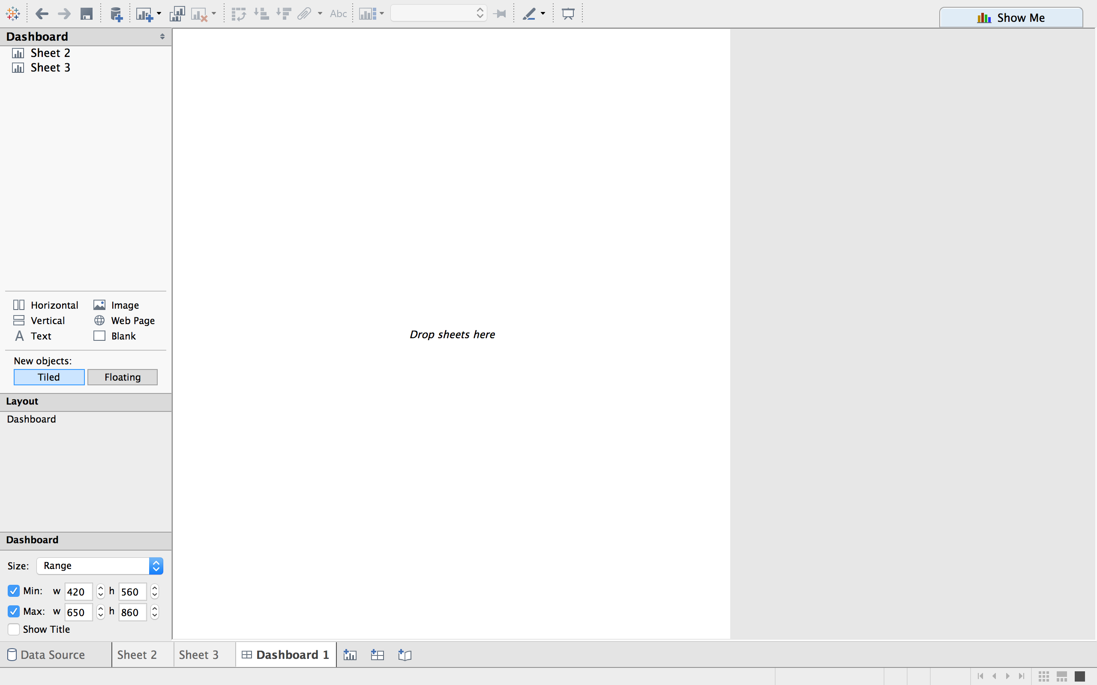

For a new sheet click on the new sheet icon at the bottom of the page then repeat steps 3-5

1. **Visual Dashboard**

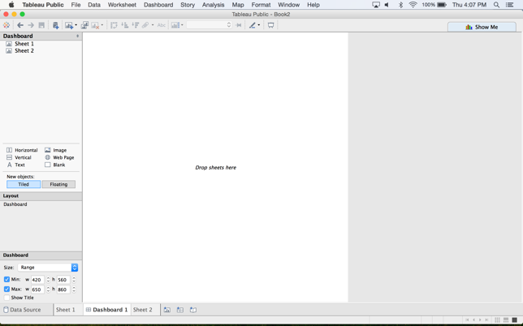Once all the graphs are created, click on the dashboardicon where you can display all of the graphs.

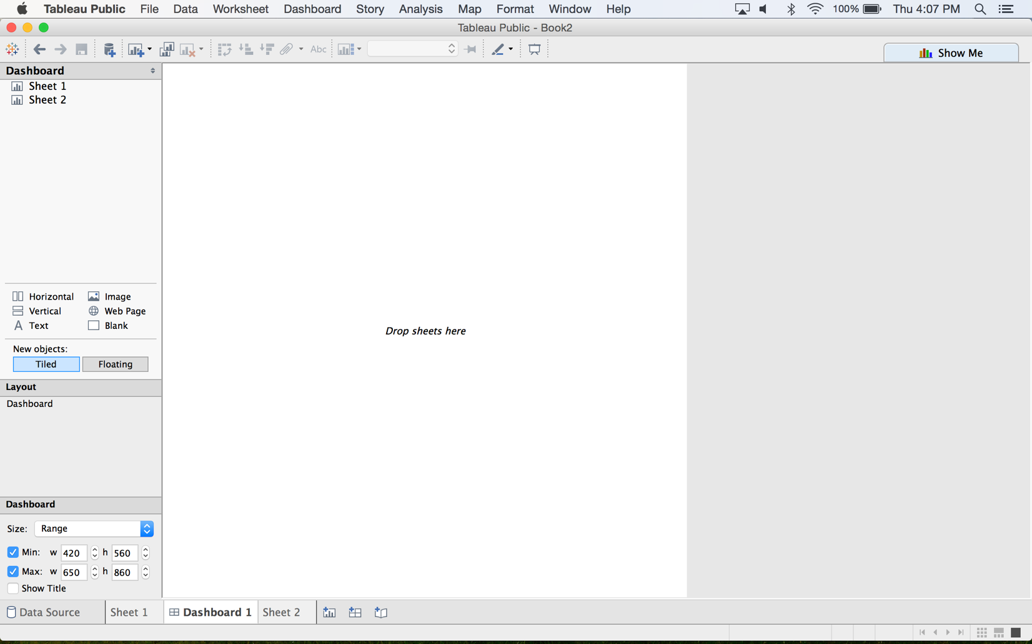

All the sheets you have created will show up under **Dashboard**. Drag the sheet(s) you want and drop them on the blank space to arrange them.